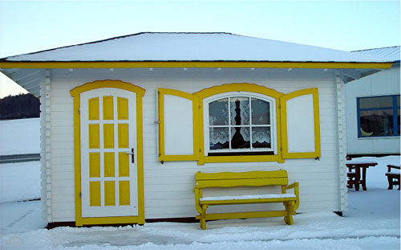 | 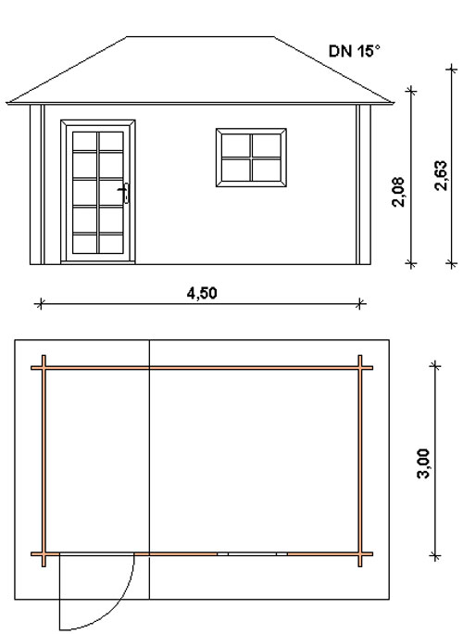
Nida-Tyla Log Cabin - from £2660
Roof projection: Front 1.10 m
Back 0.20 m
Side 0.30 m

Size: 4.5m x 3.0m
Walls: made from 45 mm (or 60mm) double tongue and groove logs
Floor: 20 mm tongue and groove floor boards on the impregnated base frame
Roof: 20 mm tongue and groove roof boards
Door: 1 glued cartridge door 90/196 with seal
Windows: 1 double-glazed 120/94 tilt ‘n‘ turn unit

Extras:

60mm instead of 45mm Call for Price
Roof Insulation Call for Price
Roof Tiles Call for Price

